Dear Parents and Students,

We are excited for the upcoming 2025-2026 school year at Farragut Middle School. We will be having Instrument Selection nights where rising 6th graders can come to the FMS band room and try-out instruments! Please scan the QR Code to complete the Google Form which will ask for basic information, sign-ups for one of the selection nights, and include videos on all of the available instruments for the upcoming 2025-2026 school year.

Once you have attended the Instrument Selection Night, played the instruments that interest you, and spoken with the directors, then you can officially choose the instrument you will be playing.

We hope you understand that each instrument class has a specific maximum student allotment due to the number of resources and facilities available to our students. Students will more than likely get their first choice, but it will be necessary to choose a second due to scheduling and class sizes.

**Instrument Selection Night Schedule:**

* **Monday, March 31st from 4:00 p.m.- 6:00 p.m.**
* **Tuesday, April 1st from 4:00 p.m.- 6:00 p.m.**
* **Wednesday, April 2nd from 4:00 p.m.- 6:00 p.m.**
* **Thursday, April 3rd from 4:00 p.m.- 6:00 p.m.**
* **Friday, April 4th from 4:00 p.m.- 6:00 p.m.**

We are excited you are joining band and are looking forward to meeting you!

All the best,

Your FMS Band Directors

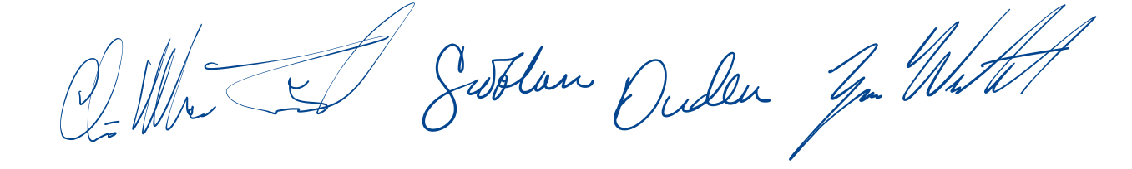

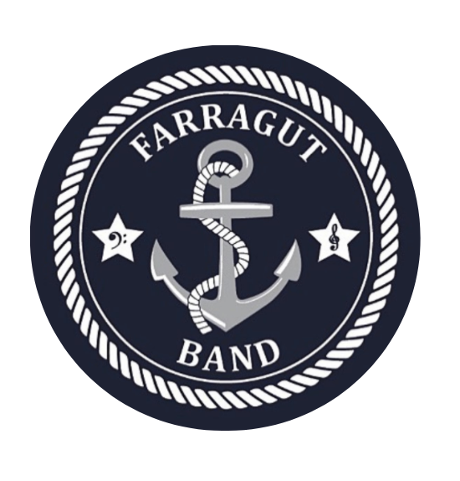

Please contact us if you have any questions:

Chris MacTavish: chris.mactavish@knoxschools.org

Zane Winchester: zane.winchester@knoxschools.org

Siobhan Duden: siobhan.duden@knoxschools.org